Luke Smotherman lds6427

Abner Koffi ack7403

Part 1:

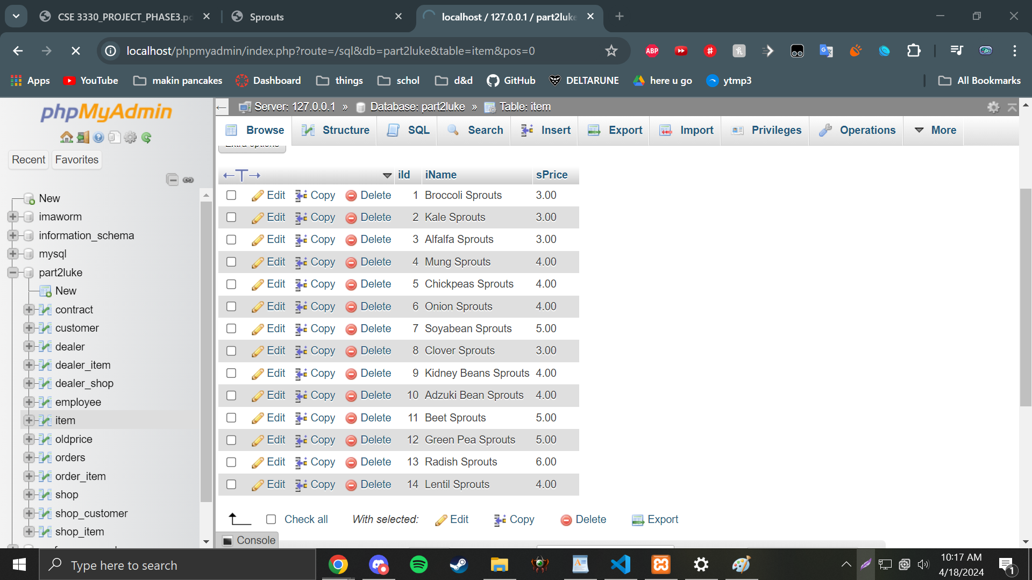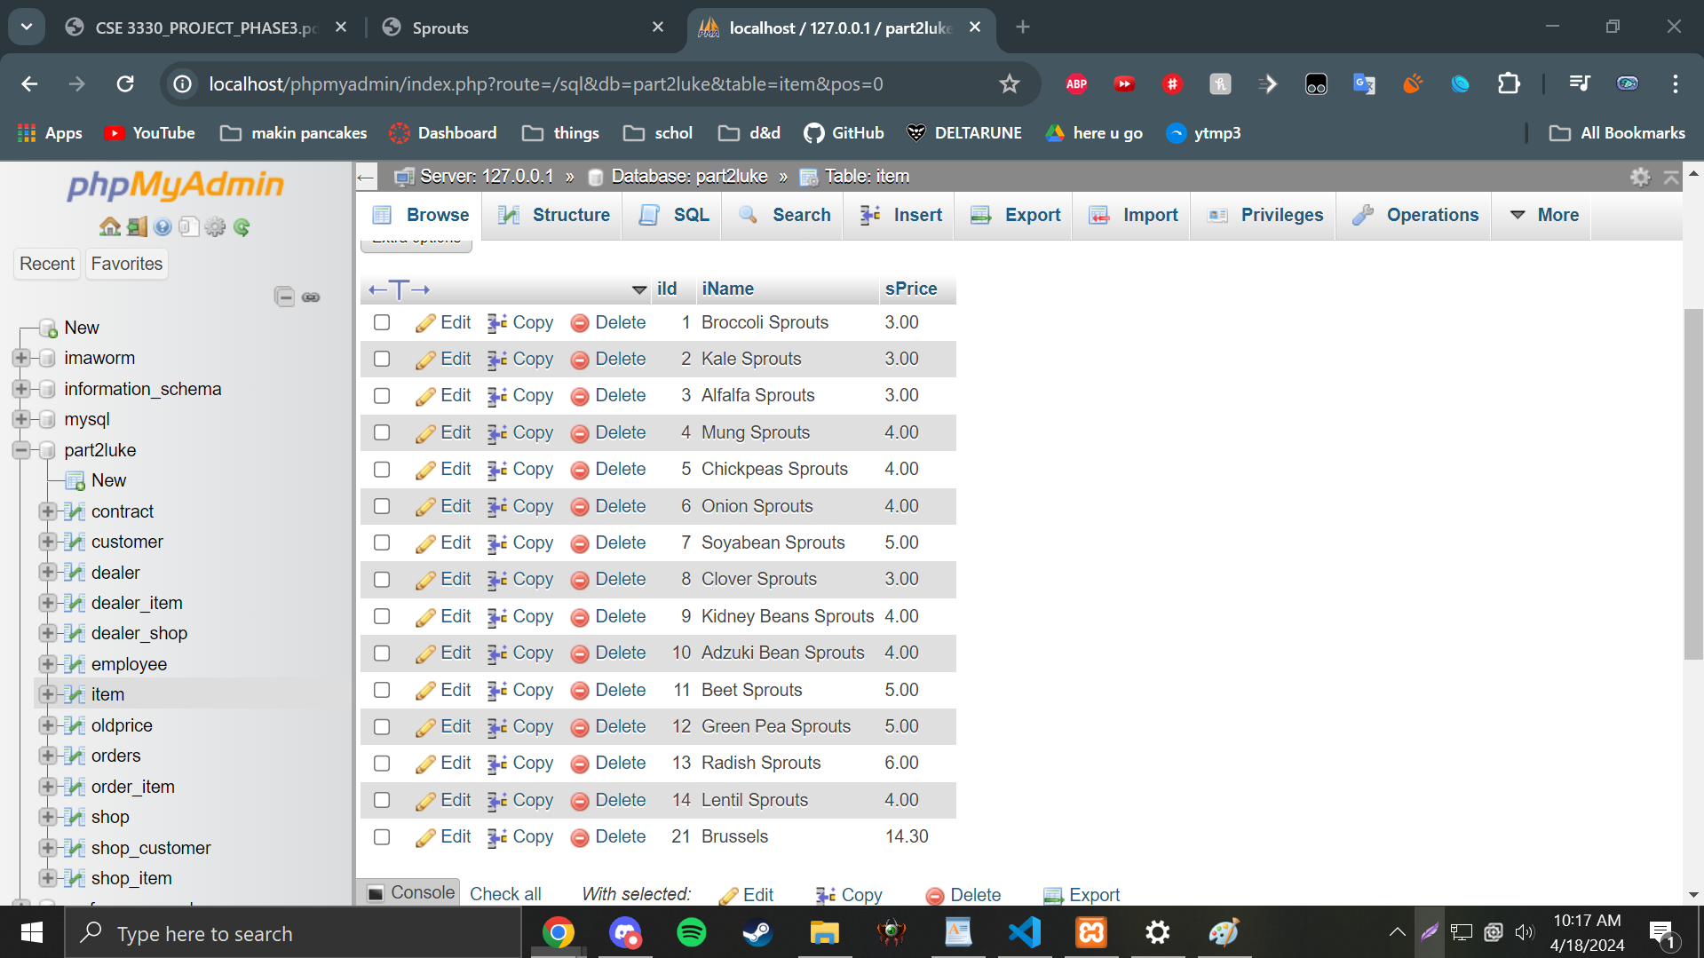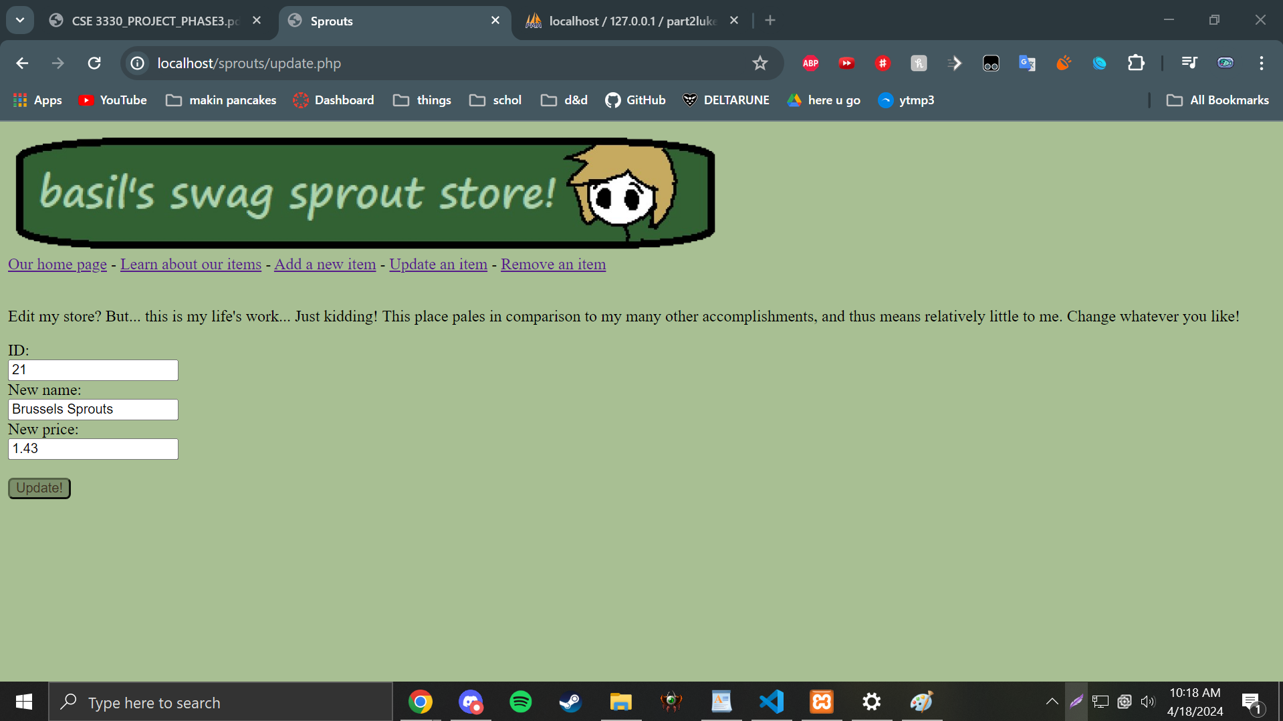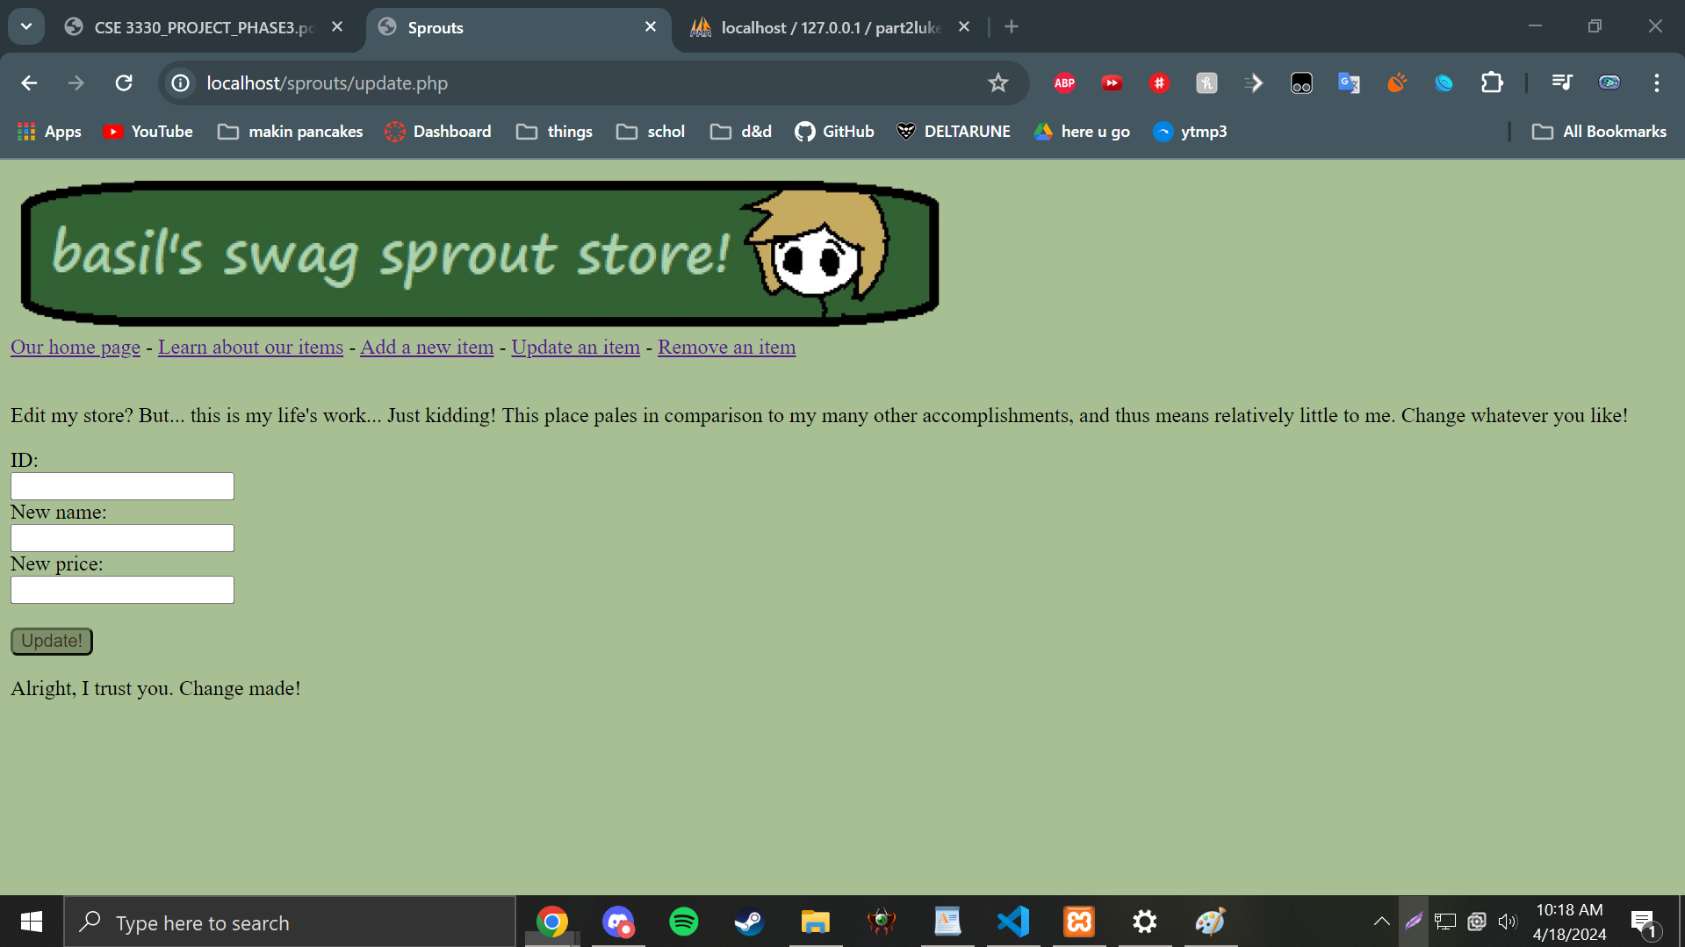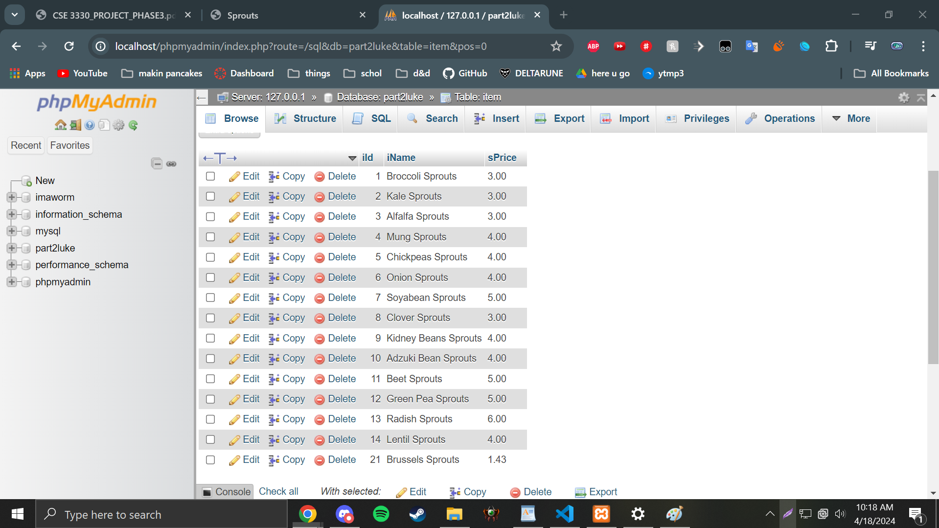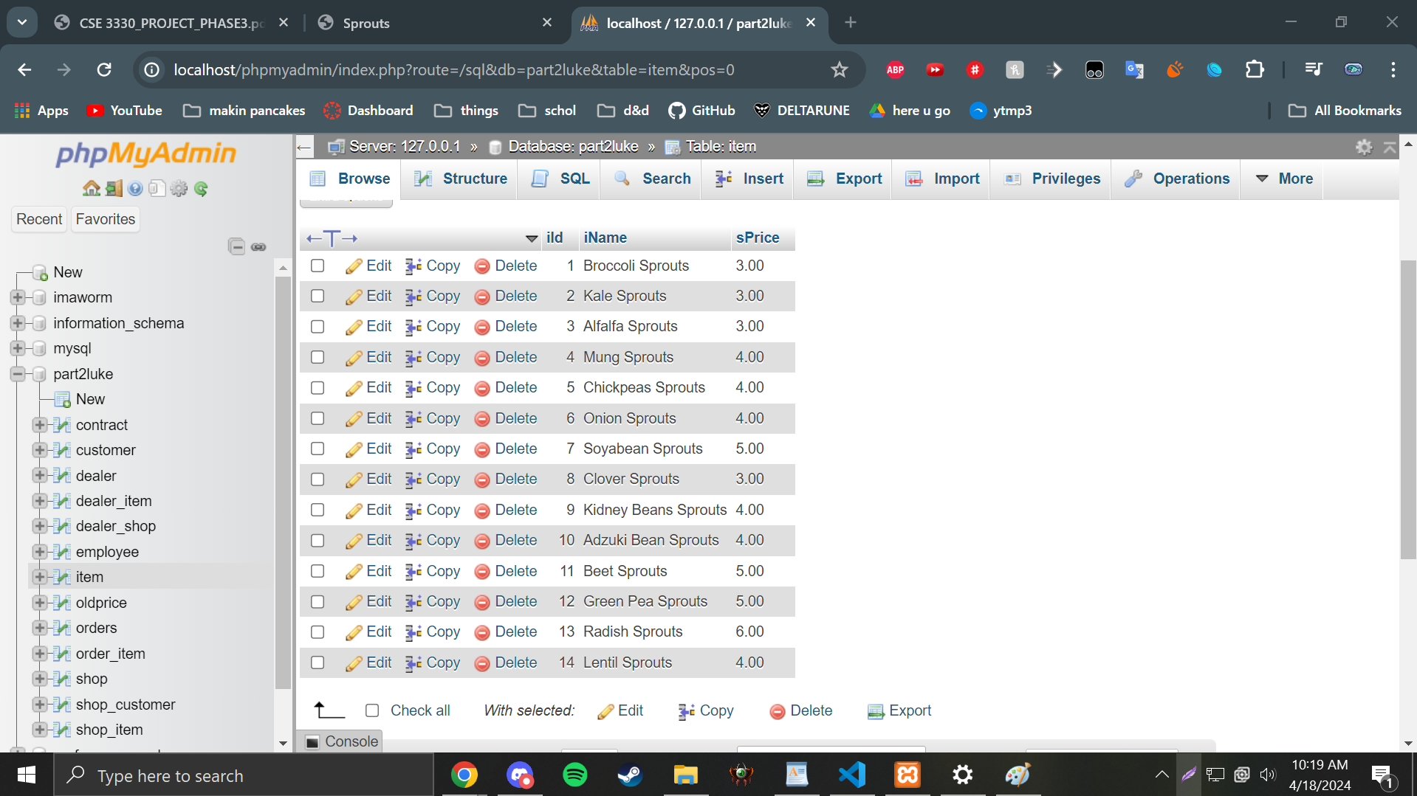

PART 2:

VIEW.)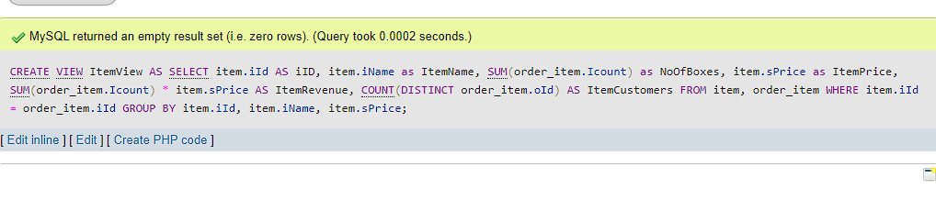CREATE VIEW ItemView AS SELECT item.iId AS iID, item.iName as ItemName, SUM(order_item.Icount) as NoOfBoxes, item.sPrice as ItemPrice, SUM(order_item.Icount) * item.sPrice AS ItemRevenue, COUNT(DISTINCT order_item.oId) AS ItemCustomers FROM item, order_item WHERE item.iId = order_item.iId GROUP BY item.iId, item.iName, item.sPrice;

1.)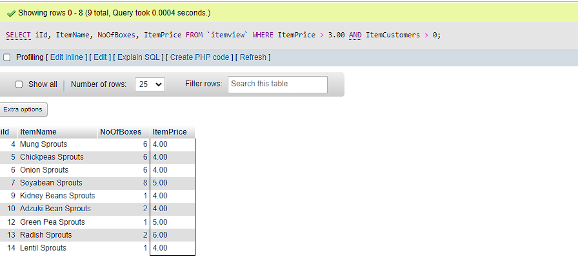SELECT iId, ItemName, NoOfBoxes, ItemPrice

FROM `itemview`

WHERE ItemPrice > 3.00 AND ItemCustomers > 0;

2.)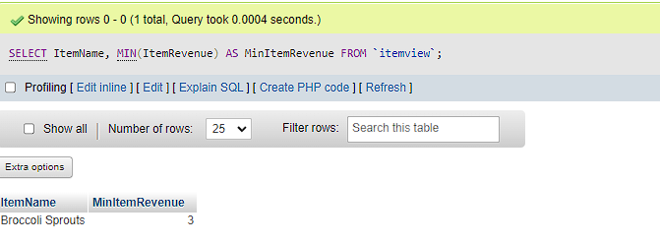SELECT ItemName, MIN(ItemRevenue) AS MinItemRevenue

FROM `itemview`;

3.)

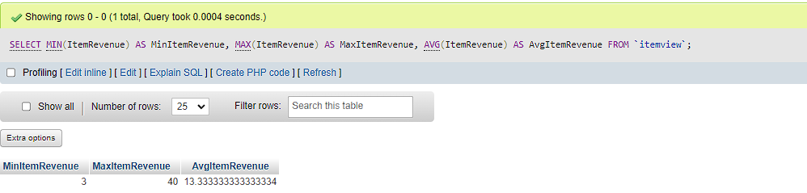SELECT MIN(ItemRevenue) AS MinItemRevenue, MAX(ItemRevenue) AS MaxItemRevenue, AVG(ItemRevenue) AS AvgItemRevenue

FROM `itemview`;

4.)

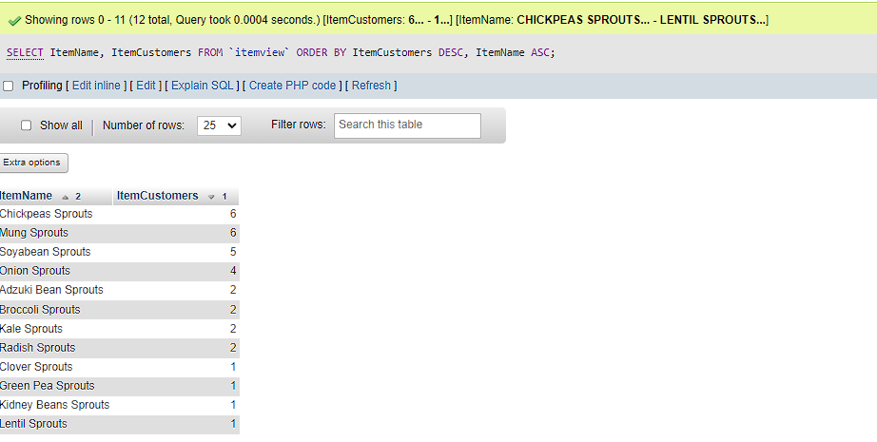SELECT ItemName, ItemCustomers

FROM `itemview`

ORDER BY ItemCustomers DESC, ItemName ASC;

5.)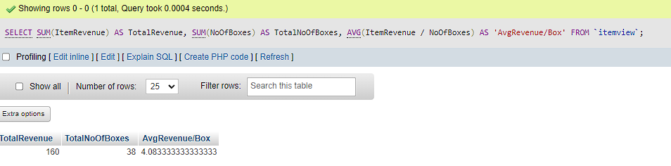SELECT SUM(ItemRevenue) AS TotalRevenue, SUM(NoOfBoxes) AS TotalNoOfBoxes, AVG(ItemRevenue / NoOfBoxes) AS 'AvgRevenue/Box'

FROM `itemview`;